 | 1
 |  |  |  |  | 2 |  | -
 |  | 3
 |  |  | 4
5
 |  |  |  |  | 6
7
8
8 | 9
 | 10
11
 |  | `12
 |  |  |  |  | 13
 |  |  | 14
 |  |  |  |  | 15
 |  |  |  | 16
 | 17

The questions
- One of the Stallone’s characters, whose favorite phrase was “ I am the law”
- The movie about the group of people who have some differences its plot was based on the popular comics.
- The famous director, who directed “ the Star Wars” , “ The Terminator” , etc.
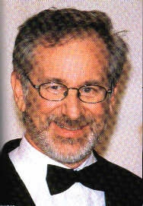
- The most popular film Character.
- The name of a girl, the character from “ The Friends” , the famous TV soap-opera, Jennifer Aniston played her.
- The film,which got 11 Oscars.
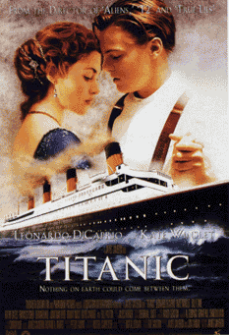

- French actress, who starred in “Braveheart”, and “ Anna Karenina”.


- A second name of an actor, who starred in the world-popular “The X-files”.
- The park where the children and parents can have fun together, which will celebrate its fiftieth anniversary in 2005.
- A name of an actor who played James Bond in last films about this famous spy.
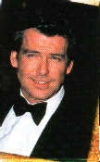

- An actor, who starred in “Zorro” . He is of Spanish origin.
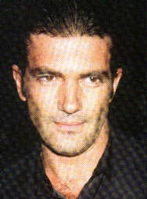

- Today this actor, who was born in Austria, is the governer of California .
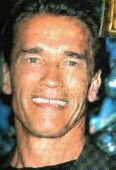

- An Ukrainian director, who made such films as “Arsenal”, and “ Zemlia”. The Kyiv Film studio was named after him .
- The name of an actor who starred in three parts of the action movie “ Hard Die”.


- A famous American director, Conducted “ The Titanic”.
- This Actor Starred in “Sleepy Hollow”, “ Chocolate”, “ From the Hell”.
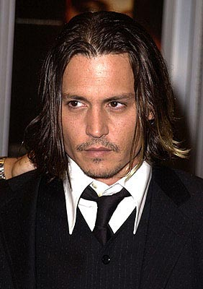

- The famous gold Statuette’s name since 1931.

Make up a Puzzle and you‘ll know how a person is called , whose work is to find all the right people for the new film – the scriptwriter, the actors and actresses, the director, the director of photography, electricians , the sound mixer, the camera operator, , the editor, etc. at the end of the work he has to borrow $5-10million dollars to pay everybody.
The answers to the puzzle

